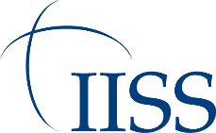
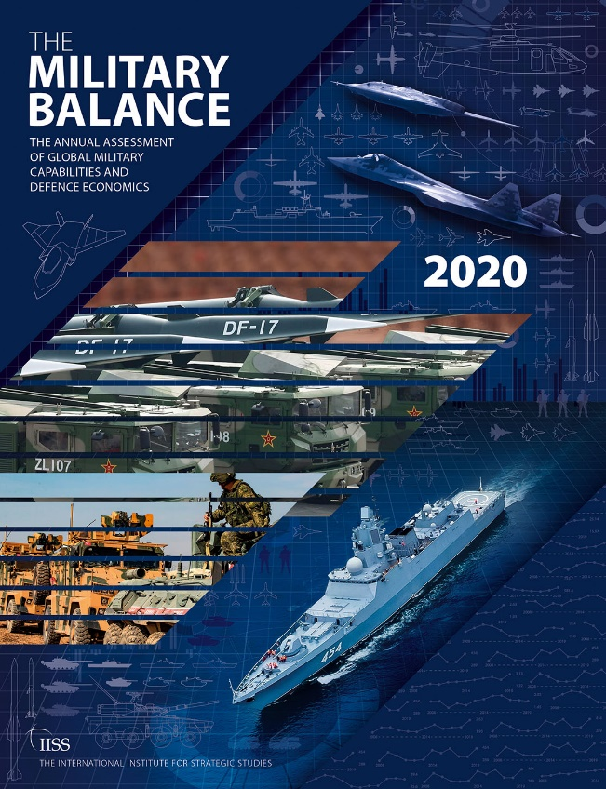
The International Institute for Strategic Studies

THEEEE
MILITARYBALANCE

THE ANNUAL ASSESSMENT OF GLOBAL MILITARY CAPABILITIES AND DEFENCE ECONOMICS

IISS Press Release

Embargo: 12:30 CET, 14 February 2020

Contact: Silje Undlien, silje.undlien@iiss.org
+44 (0)20 7395 9934

Largest global defence-spending increase in a decade show Military Balance 2020 figures released today

The International Institute for Strategic Studies (IISS) released figures from its world-leading survey of military capabilities, The Military Balance 2020, at the Munich Security Conference today (14 February) that show that 2019 saw the largest year-on-year increase in global defence spending for ten years.
In 2019, global defence spending rose by 4% over 2018, when measured in real terms, representing the highest year-on-year increase in a decade. The Military Balance 2020 also concludes that defence spending in Europe reached levels not seen since before the financial crisis, increasing by 4.2% when compared with 2018.
In both the United States and China, defence spending increased by 6.6% in 2019. Although both countries continued to increase the amount they spend, defence spending growth is accelerating in the US, while it is slowing in China.
More broadly, Asian defence spending continues to rise, as does the region’s GDP growth. IISS data shows that overall defence spending in Asia has increased by more than 50% in a decade, rising from US$275 billion in 2010 to US$423bn in 2019 in real terms.

Notes to editors
1 The International Institute for Strategic Studies (IISS) is a world- leading authority on global security, political risk and military conflict. Founded in 1958, the IISS promotes the development of sound policies that further global peace and security and main- tain civilised international relations. The IISS is renowned for its extensive global research and publications.
2 Other series of publications include: Military Balance+, The Military Balance complementary database; Iran’s Networks of Influence in the Middle East; Armed Conflict Survey,

that identifies trends in the world’s active armed conflicts; Strategic Survey: The Annual Assessment of Geopolitics; and other seminal work on nuclear deterrence and arms control, as well as emerging geopolitical and geo-economic trends. The IISS
is also renowned for its security summits, including the IISS Shangri-La Dialogue (The Asian Regional Security Summit) and IISS Manama Dialogue (The Middle East Regional Security Summit). The IISS has offices in London, Washington DC, Bahrain and Singapore.

